CSIR
Environmental Management Services

24 June 2019

South African Wind Energy Association (SAWEA)
53 Dudley Road
Corner Bolton Avenue
Parkwood
Gauteng
2193

Dear SAWEA Members

Background

The Council for Scientific and Industrial Research (CSIR) has been appointed by the Department of Environmental Affairs (DEA) to manage and undertake Phase 2 of the Strategic Environmental Assessment (SEA) for the effective and efficient rollout of large-scale wind and solar PV developments (“Phase 2 Wind and Solar PV SEA”) in South Africa. The overall purpose of this is to identify additional Renewable Energy Development Zones (REDZs) on a National Level. Based on the outcomes of the "Phase 1" Wind & Solar PV SEA undertaken in five provinces in 2014, the DEA has identified a need for additional REDZs to be determined.

The Phase 2 Wind and Solar PV SEA Project Team is undertaking a data gathering exercise involving renewable energy generators, specifically wind and solar PV (excluding rooftop installations), on the potential high priority energy generation areas to assist with the prioritsation of the eight (8) Phase 2 Focus Areas which have been identified in this iteration of the SEA.

This exercise will inform which of the eight focus areas will be taken forward as REDZs. The identification of Focus Areas to become REDZs is based on specialist assessments, public consultation and industry planning on developing large scale solar PV or wind developments. This SEA is commissioned to assist in the strategic alignment of various development initiatives, thus this the exercise's outcome is seen as a key component of the SEA.

Exercise Instructions:
The exercise requests that you rank the eight (8) Focus Areas that best reflects planned solar PV or wind development within South Africa. The selection should be based on; any immediate, intermediate and or future plans, current knowledge of the industry and transmission development plans. Please limit submission to one completed form per organisation. However, more than one form submission per organization will be considered under certain circumstances.

Name:
Company:
Designation:
Physical Address
Email:
Phone

Please rank the Focus Areas; with the value ‘1’ being the most preferable to be taken foreward as a REDZ (Please use Focus Area names as dispalyed in Figure 1).

Selection and Ranking: | Focus Areas Name
1
2
3
4
5
6
7
8

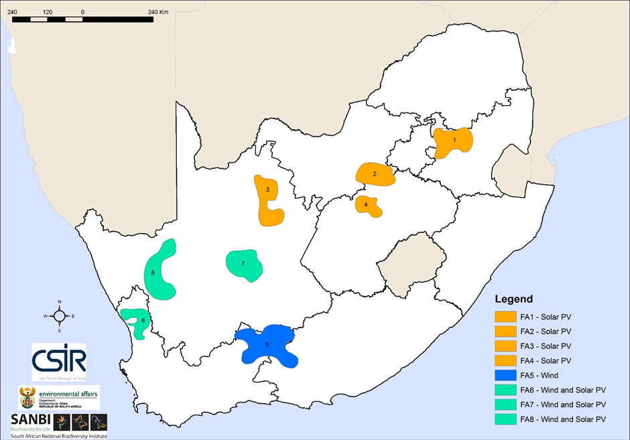
Figure 1: Phase 2 Wind and Solar PV Focus Areas

The form can also be downloaded on the project’s website: https://redzs.csir.co.za/?page_id=595.

Submission requirements:
We request that the required feedback is provided by 12 July 2019. Please submit completed forms to redzs@csir.co.za. All submission will be kept confidential. Only aggregated results are used in the SEA, which will be released to the public.

The Project Team would like to thank you in advance for your submissions and your assistance with informing the SEA.

Yours sincerely,

Abulele Adams
Email: aadams1@csir.co.za
Tel: 021 888 2567
SEA Project Manager
CSIR Environmental Management Services

